Alex Petcu Biography - 200 words
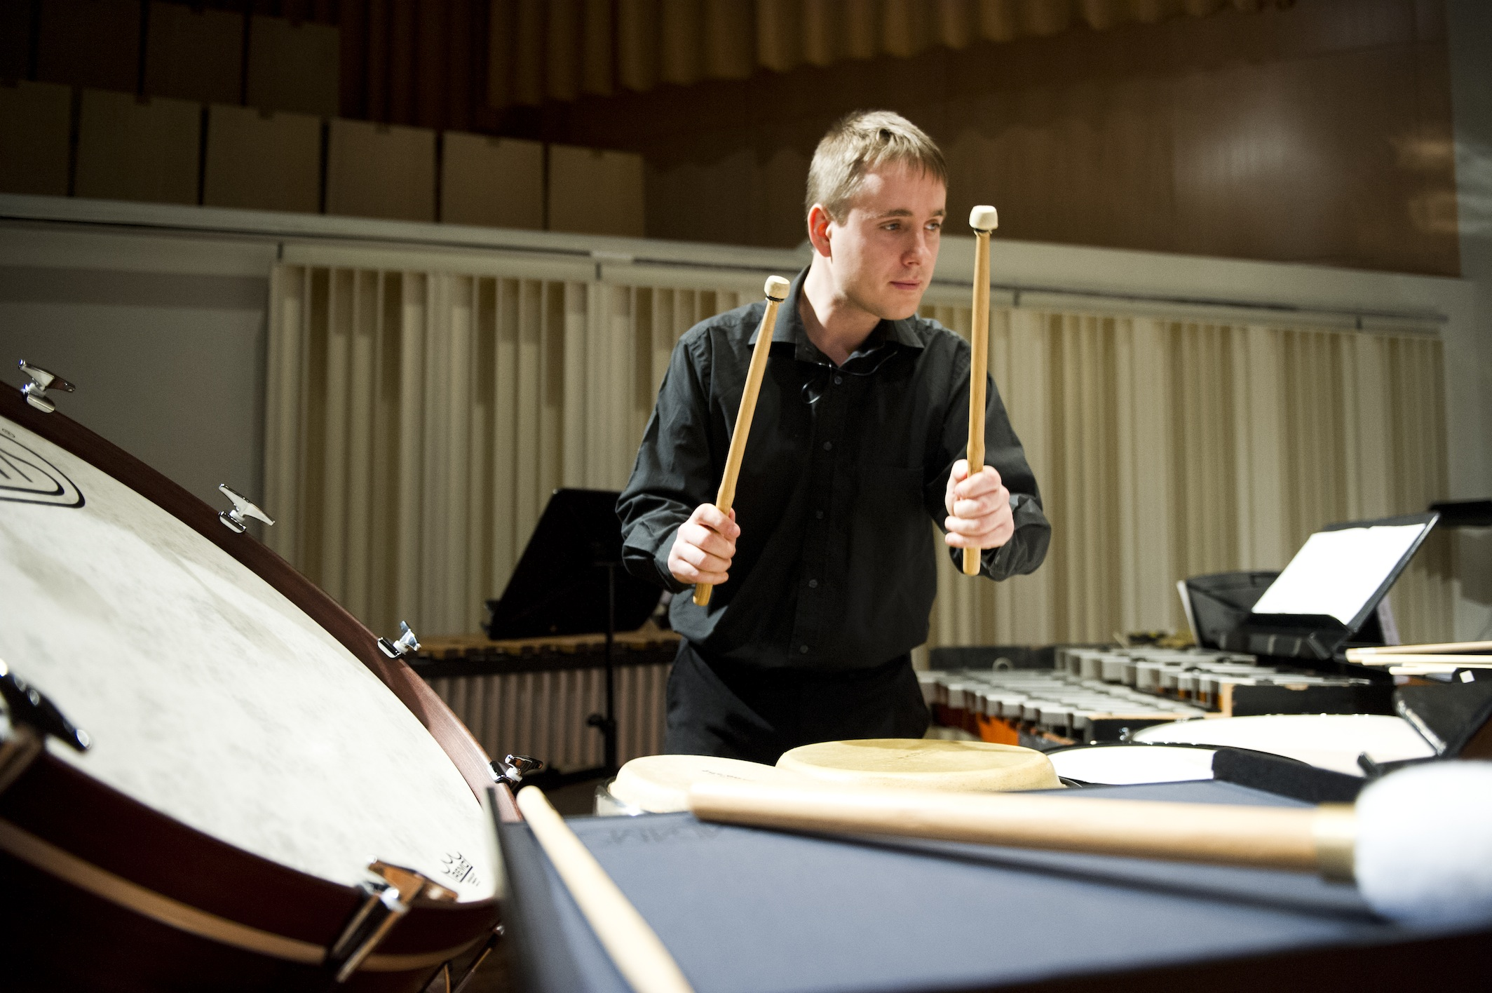

An Irish musician of Romanian origin, Alex is quickly establishing himself both nationally and internationally as a percussionist of the finest calibre. His debut album, "Alex Petcu: In Time", released on the RTE lyric fm label, showcases both seminal works and new contributions to the percussion repertoire.

An active freelance musician, Alex performs with a wide variety of ensembles and in a range of settings. In particular, he enjoys working with composers to create new works that push the boundaries of what music for percussion can be. He is a member of Crash Ensemble. Their most recent work include the world premieres of large scale works by Andrew Hamilton, Barry O’Halpin and Donnacha Dennehy. He has also commissioned several new works for viola and percussion duo with Nathan Sherman, some of which have been released on CD on the Ergodos label. He also runs his own ensemble, the Bangers and Crash Percussion Group who play everything from intimate concerts and workshops, to massive projects that feature hundreds of instruments!

Aside from his performing activities, Alex is also assistant lecturer in percussion at the MTU Cork School of Music. He holds an MA in music performance, and an MSc and BSc in physics.

