Alex Petcu Biography - 100 words
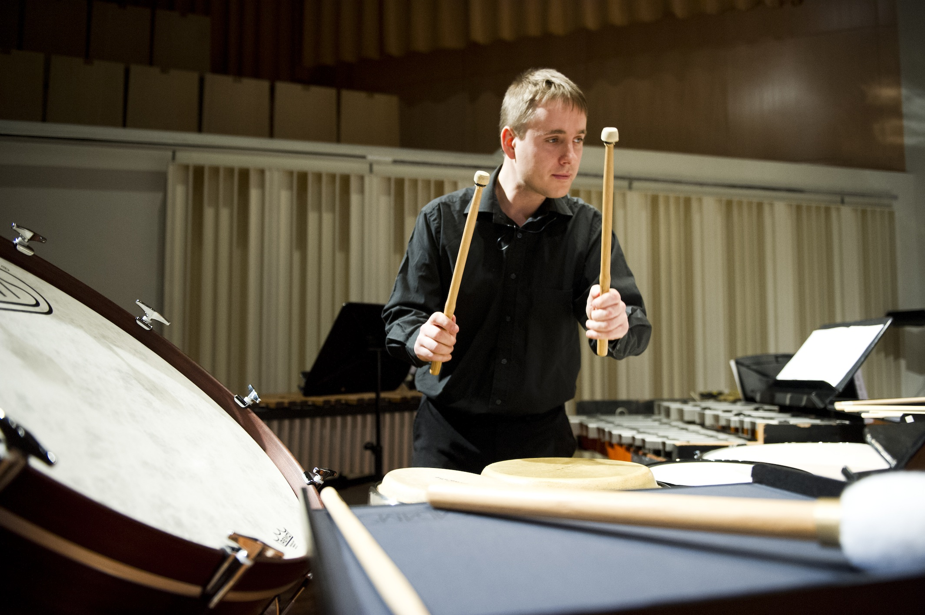

An Irish musician of Romanian origin, Alex is quickly establishing himself both nationally and internationally as a percussionist of the finest calibre. His recent appearances as a soloist with both RTE orchestras and Irish Chamber Orchestra are some of his main highlights so far.

An active freelance musician, Alex performs with a wide variety of ensembles and in a range of settings including the Crash and Hard Rain Ensembles, Bangers and Crash Percussion, the professional orchestras in Ireland, as a soloist at various festivals, as a theatre musician and much more.

His debut album, "Alex Petcu: In Time" has recently been released on the RTE lyric fm label.

